JupiterOne is effectively a NoSQL database—specifically a Graph Database (labeled property graph model). But it's not schema-less like MongoDB; it has a semi-rigid ontology (schema)
1. The Database Type: Labeled Property Graph
Not relational (no tables, no foreign keys)
Not document (not JSON blobs with nested arrays)
It's a graph: Nodes (entities) + Edges (relationships) + Properties (key-value pairs)
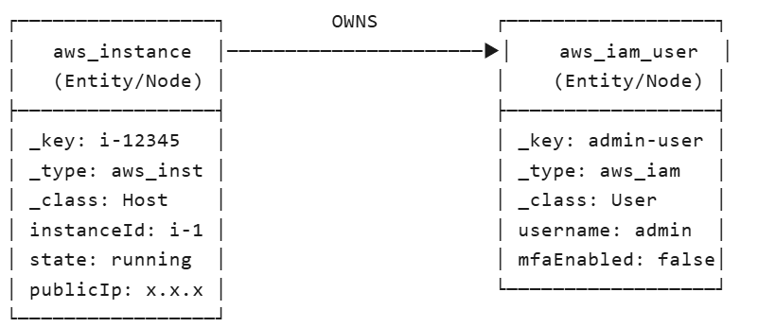
2. The Schema Structure (Ontology)
JupiterOne uses a hierarchical class system (like object-oriented inheritance):
Entity Schema:
Every entity has standard metadata (enforced by J1) + custom properties (from the source tool):
- _key: Unique ID (string). Usually source-native ID like i-0abc123 or CVE-2024-1234
- _type: Specific type. Examples: aws_instance, crowdstrike_device, qualys_vulnerability
- _class: Abstract category. Examples: Host, Device, Finding, Account, Repository
- _createdOn, _updatedOn: Timestamps managed by J1
- _version: Integer for optimistic locking
Relationship Schema (The Edges):
(Entity A) --[RELATIONSHIP_TYPE]--> (Entity B)
Relationship Structure:
- Verb: HAS, CONTAINS, OWNS, CONNECTS, IDENTIFIED, MANAGES
- Direction: Source → Target (unidirectional, though you can query both ways)
- Properties: _createdOn, _fromEntityId, _toEntityId, optionally lastSeen, port, protocol
Examples:
ServiceNow (CMDB CI) --MANAGES--> AWS Instance
Qualys (Scanner) --IDENTIFIED--> Vulnerability
Vulnerability --AFFECTS--> AWS Instance
3. NoSQL Characteristics
Schema Flexibility (Semi-Structured):
- New properties can appear anytime (if AWS adds a new API field, J1 ingests it)
- No rigid column definitions like Vertica/Postgres
- But: _class and _type are strict taxonomy—you can't invent new classes arbitrarily
Query Model:
- Not SQL: You can't SELECT * FROM aws_instances WHERE...
- Graph Traversal: FIND aws_instance WITH state='running' THAT HAS vulnerability WITH severity='Critical'
Storage Implementation:
- Likely uses a graph database backend (Neo4j, Amazon Neptune, or proprietary)
- Optimized for relationship traversal ( JOINs are cheap—relationships are first-class citizens)
4. The "Schema" Problem for Your Export
Json -> Relation table
Option A: Star Schema (Recommended)
- dim_assets table (one row per entity)
- dim_relationships table (source_key, target_key, relationship_type)
- fact_findings table (vulnerabilities linked to assets)
Option B: JSON Columns (Easier, but slower)
- Store relationships as JSON array in a Vertica VARCHAR column (flexible but bad for querying)
Option C: Wide Denormalized Tables (What analysts probably want)
- Flatten the graph: aws_instance_id, volume_id, security_group_id, owner_id all in one row (loses multi-valued relationships)

The JupiterOne Data Model (J1DM)
Study:
- Entity Classes: Account, Host, Device, Finding, CodeRepo, User, Group
- Relationship Verbs: The allowed relationship types between classes
- Property Normalization: How J1 standardizes properties across sources (e.g., ipAddress vs privateIpAddress)

J1DS Export Format:
- Does J1DS export entity snapshots (current state) or change logs (deltas)?
- Are relationships exported as separate edge files or embedded in node JSON?

JupiterOne data model concepts:
Asset: Anything in your environment that J1 tracks
- An EC2 instance in AWS
- A laptop monitored by CrowdStrike
- A GitHub repository
- A vulnerability found by Qualys
- A user in Okta
Class: Defines what an asset is conceptually in a high level.
- parent class in OOP
- It determines what properties an asset should have and what relationships it can participate in.
- Key Point: Class determines behavior. A Host can CONNECT to another Host. A Finding can IDENTIFY a vulnerability on a Host. A User can OWN a CodeRepo

Asset | Class | Why
AWS EC2 Instance | Host | It's a computing device
CrowdStrike Sensor | Agent | It's software monitoring a device
AWS S3 Bucket | DataStore | It stores data
Qualys Vulnerability | Finding | It's a discovered security issue
GitHub Repository | CodeRepo | It stores source code
Okta User | User | It's a human identity
Type: The specific "flavor" of the class—indicates which tool/source created it and the specific schema.
- While Class says "this is a car," Type says "this is a 2024 Tesla Model 3."

Class | Type | Source
Host | aws_instance | AWS API
Host | crowdstrike_device | CrowdStrike API
Finding | qualys_vulnerability | Qualys API
Finding | wiz_finding | Wiz API
Account | aws_account | AWS Organizations
Repository | github_repo | GitHub API
Properties: Key-value pairs describing the asset. These are the columns in your eventual SQL tables

  - Standard Properties (Present on almost all assets):
_key: Unique ID (e.g., i-0abc123, CVE-2024-5678)
_class: The class (e.g., Host)
_type: The type (e.g., aws_instance)
_createdOn: When J1 first saw this asset
_updatedOn: When J1 last updated this asset
name: Human-readable name
displayName: Pretty name for UI
  - Source-Specific Properties (Tool-dependent):
    - aws_instance:
{
"instanceId": "i-0abc123",
"instanceType": "t3.large",
"state": "running",
"vpcId": "vpc-12345",
"publicIpAddress": "54.1.2.3",
"tags": {"Owner": "Team-A", "Environment": "Prod"}
}
    - crowdstrike_device:
{
"deviceId": "12345",
"hostname": "CORP-LAPTOP-01",
"osVersion": "Windows 11",
"agentVersion": "6.42",
"lastSeen": "2026-04-16T10:00:00Z"
}
Hierarchy Relationship:
Class (Host)
├── Type: aws_instance
│ └── Properties: instanceType, vpcId, publicIp...
├── Type: crowdstrike_device
│ └── Properties: agentVersion, lastSeen...
└── Type: azure_vm
└── Properties: vmSize, resourceGroup...

J1DS Export Implications:
- Schema Design Strategy: Don't create one giant "assets" table with all possible properties. Instead:
  - Option A: Type-specific tables (Recommended)
    - table_aws_instance (columns: instanceId, instanceType, vpcId...)
    - table_crowdstrike_device (columns: deviceId, hostname, agentVersion...)
    - table_qualys_finding (columns: qid, severity, cvssScore...)
  - Option B: Generic EAV (Entity-Attribute-Value)
    - assets table: (_key, _type, _class, name)
    - properties table: (_key, property_name, property_value)
    - Messy for SQL querying, very flexible
  - Option C: Supertype table with JSON column
    - assets table: (_key, _type, _class, name, attributes JSON)
    - Store varying properties as JSON in Vertica
    - Good compromise for semi-structured data
- The _key is Your Primary Key:
  - Always unique across all types (even if two tools have ID "12345", they won't collide because _key includes context)
  - Use this to join with the relationships table
- Property Type Consistency
J1 is schemaless-ish, but you need rigid types for Vertica:
- severity comes as string "5" from Qualys, integer 5 from Wiz—normalize in your ETL
- Dates: ISO8601 strings in J1 → TIMESTAMP in Vertica
- Tags: Often arrays/objects in J1 → normalized to separate tag table or concatenated string

